Description:

For my project I will be building a experience centered around Alice in wonderland fairy tail. Particular the beginning when she follows white rabbit and then falls down a hole. And later drinking and eating suspicious substances to fit through a door.

At the very beginning the user would be fooled by dark and grim lighting until he presses start and the magical forest would be revealed. The player would be standing in a small meadow surrounded with trees. In the center there would be opening with the white rabbit standing in it. Player will follow him. And fall down a rabbit hole in which the player will have trial of eating and drinking. Where key is placed on a higher ledge and requests player to become big. And the door is to small and requires player to become small.

Features and dependencies:

Objects and animation:

1. White rabbit (possibly low poly watch) + Cave or a hole.

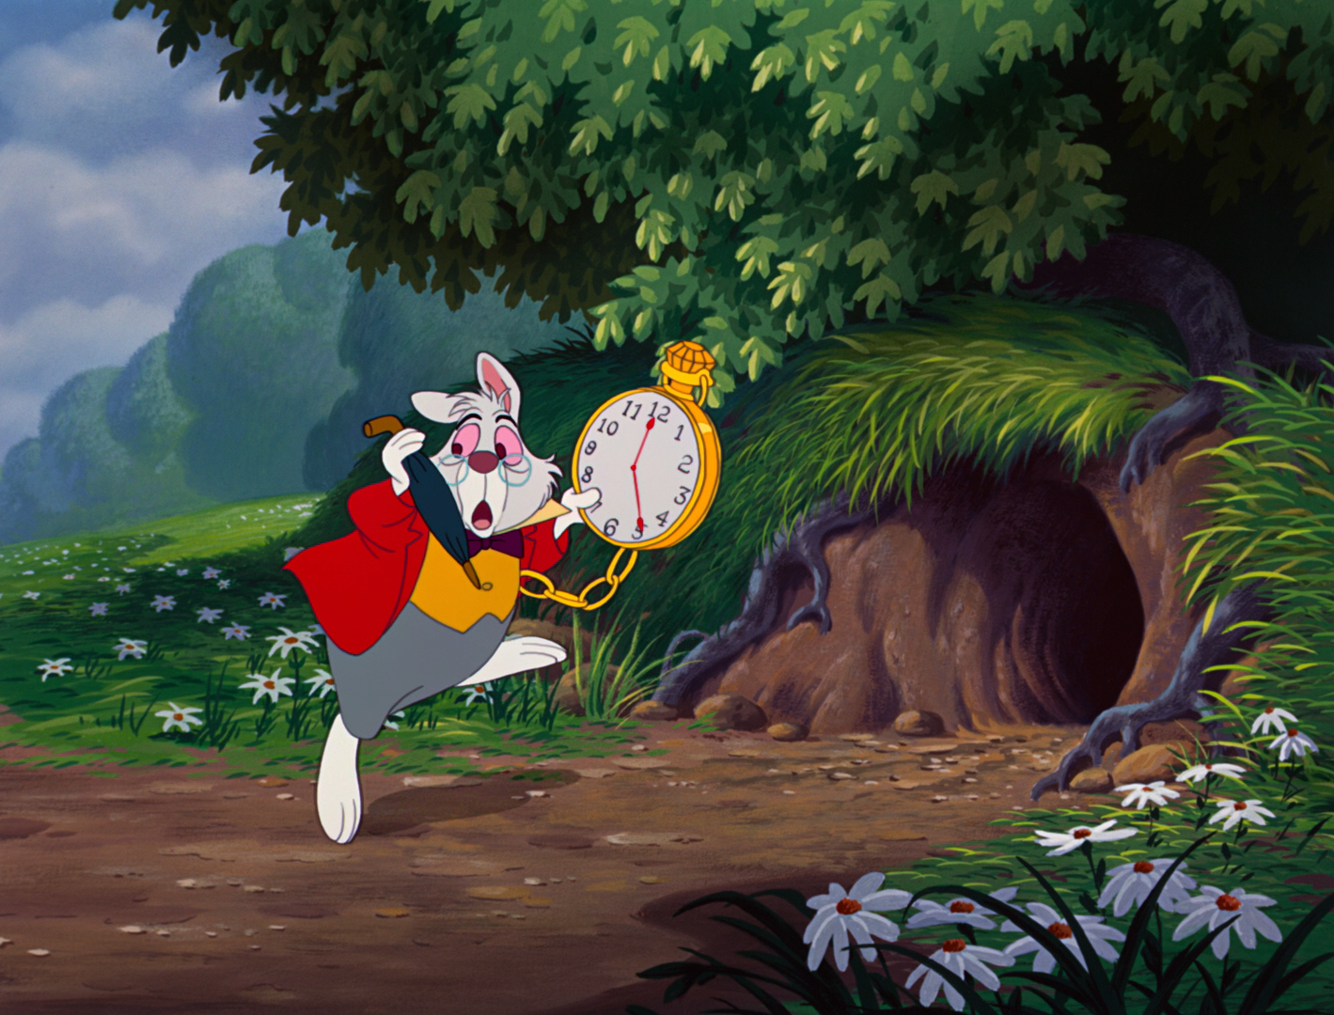

2. Trees props

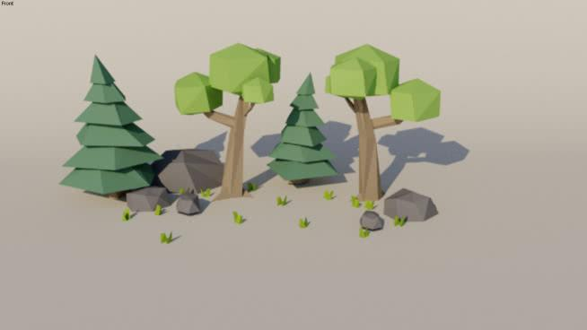

4. Table + key

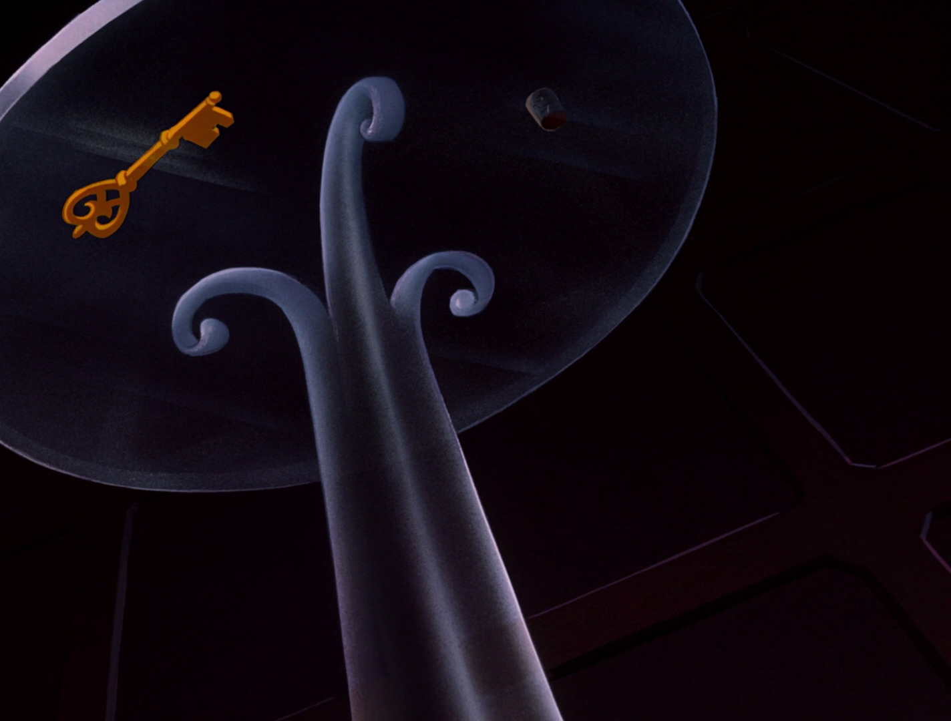

5. Door

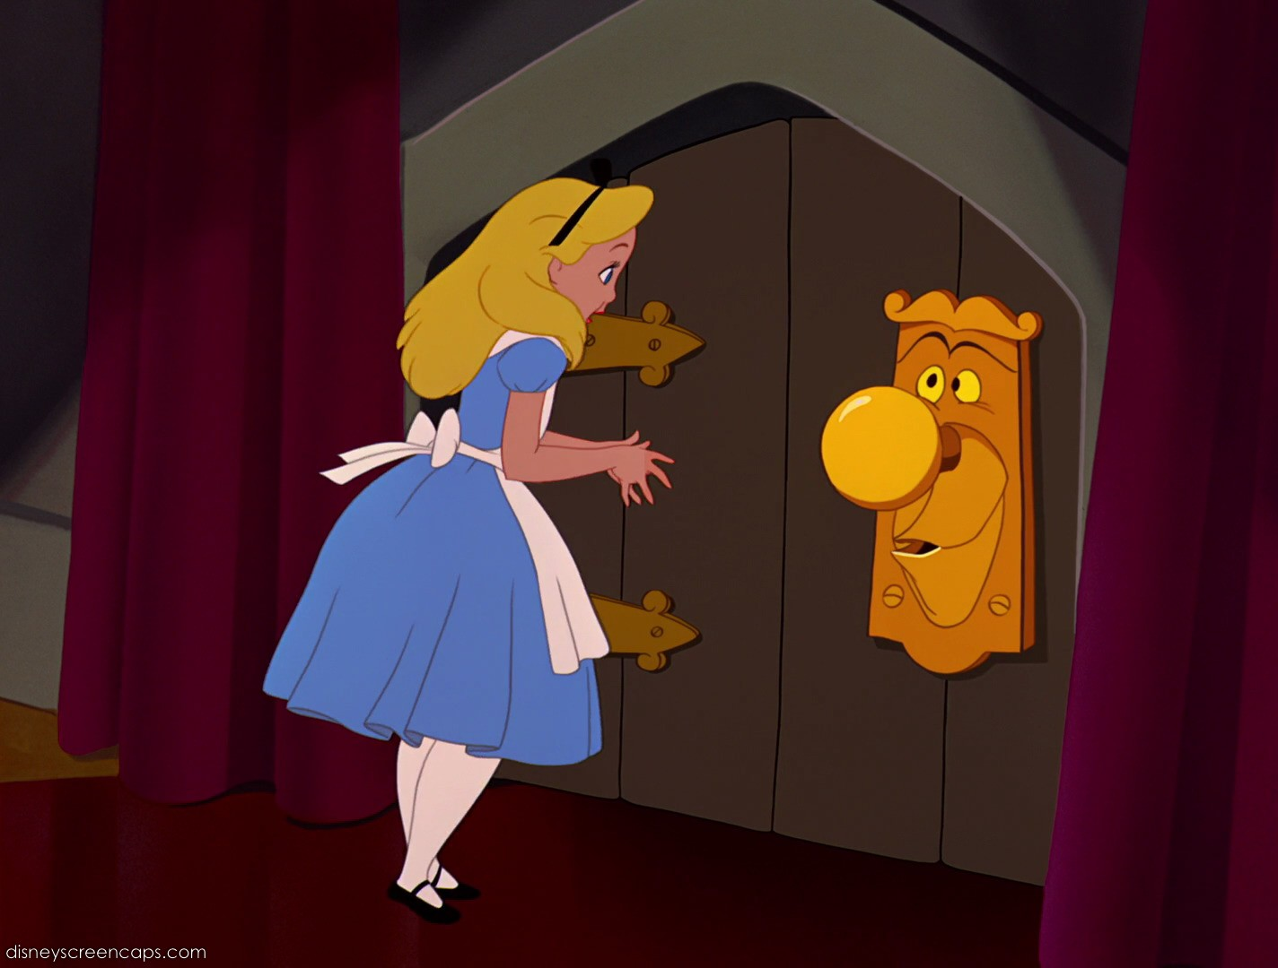

6. Potion + cookie

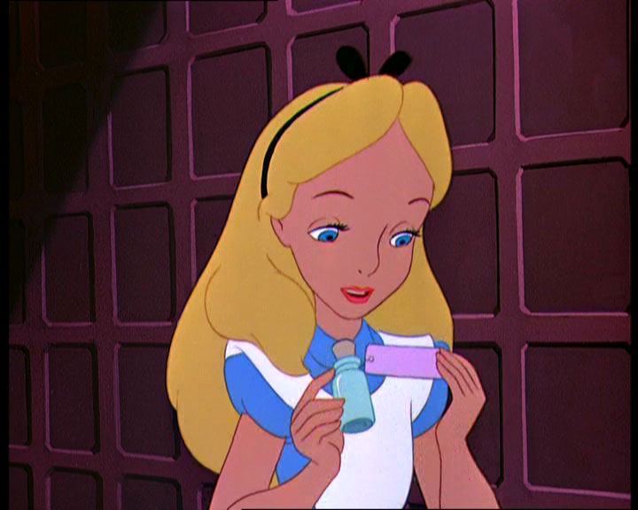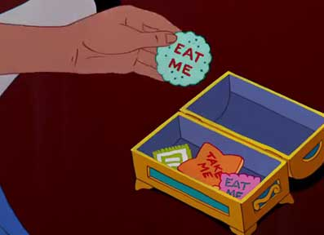

2. Game Loop

1. Light change after press play
2. Follow White Rabbit by using him as a waypoint
3. Physical falling down a hole
4. Game mechanics for player while playing scaling puzzle:

I: eat cookie to become larger.

II: Get the key

III: Drink potion to become smaller .

IV: Go through a door.

3. Other effects

1. Particle effect on a flowers to appear forest more magical
2. Fully animated running rabbit with watch.
3. Scale changing for environment thought the animation.
4. Tune that would provide sense of enchantment
5. Spatial sound effect for Potion and the door.

Capstone Scoping

Features and dependencies revisited:

1. White rabbit ~~(possibly low poly watch)~~

**Was replaced by photogrammetry of my own watch**

1. Trees props
2. Cave ~~or a hole~~
3. Table + Potion + cookie
4. Door
5. Key

2. Game Loop

1. ~~Light change after press play~~

**Was too expensive on a hardware and was replaced by baked lighting**

1. ~~Follow White Rabbit by using him as a waypoint~~

**Using rabbit as waypoint proved to be not as intuitive so now player is using light up piles of dirt that rabbit produce.**

1. ~~Physical falling down a hole~~

**User testing showed that this effect is making players nauseous and was replaced by falling object around the player to create an illusion of falling.**

1. Game mechanics for player while playing scaling puzzle (was revisited to provide more natural experience):

I: ~~eat cookie to become larger.~~

II: ~~Get the key~~

I: Drink potion to become smaller .

II: Go ~~through~~  **to** a door.

III: **Come back and eat the cookie therefore becoming big**

IV:**Get the key and then drink a second potion to become small again**

V: **Go through to a door and see end scores**

3. Other effects

1. ~~Particle effect on a flowers to appear forest more magical~~

**Too expensive on a hardware was replace with gamification of mushrooms and poof effect on them**

1. Fully animated ~~running~~ **jumping** rabbit ~~with watch~~. **(was replaced by rabbit dropping his watch)**
2. Scale changing for environment ~~thought the animation~~.

**Itween plugin was working more natural in this situation.**

1. Tune that would provide sense of enchantment  **(done and proud)**
2. Spatial sound effect for Potion and the door.

**+ cookie, mushrooms, chess piece, rabbit and the watch sound which I recorded and edited from my own watch. (so it’s looks and sounds just like in real life :D )**